Where to obtain CDC bottle bioassay kit and instruction manuals for performing bioassay:
- FREE CDC bottle bioassay kit
  - Includes everything pictured below as well as requested technical grade insecticides
  - Programs within CONUS can request by emailing USBottleAssayKit@cdc.gov
  - Programs outside the U.S. can request by emailing bottleassay@cdc.gov
  - More info: https://www.cdc.gov/parasites/education_training/lab/bottlebioassay.html
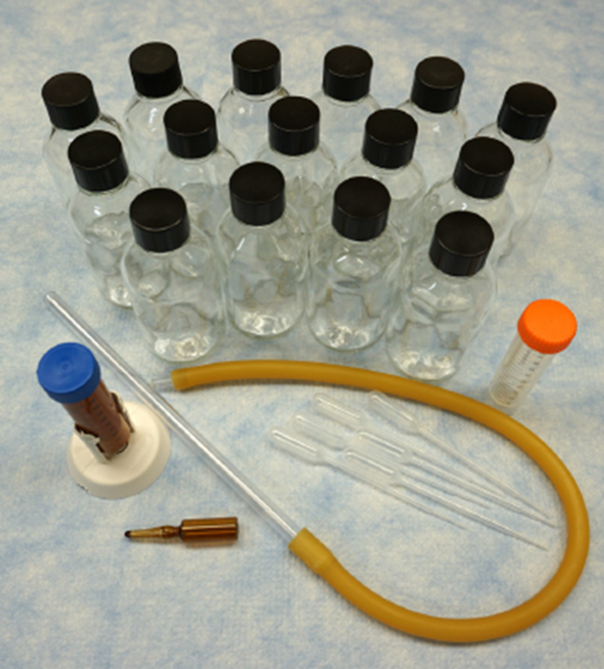
- Manuals with instructions on how to conduct insecticide resistance
  - For programs within U.S.:
    - CONUS Manual for Evaluating Insecticide Resistance in Mosquitoes Using the CDC Bottle Bioassay Kit
  - For international programs:
    - Guidelines for Evaluating Insecticide Resistance in Vectors Using the CDC Bottle Bioassay in English
      - Insert 1, Revised Box 5: Interpretation of Data for Resistance Management Purposes
      - Insert 2, Enhanced Surveillance Protocol for the CDC Intensity Bottle Bioassay
    - Guidelines for Evaluating Insecticide Resistance in Vectors Using the CDC Bottle Bioassay in Spanish
    - Guidelines for Evaluating Insecticide Resistance in Vectors Using the CDC Bottle Bioassay in Portuguese

